## Application for validating Error Detection Rules

|  |  |  |  |
| --- | --- | --- | --- |
| **Author** | **Changes** | **Version** | **Date** |
| Srikar Achanta, Technical Lead, AppD | Initial Draft | 0.1 | 09/27/2019 |

Table of Contents

Application for validating Error Detection Rules 1

Summary 1

Configuring the Host 1

Folder Structure 2

Python Application 3

## Summary

The intention of this document is to provide details for building an application for detecting problematic REGEX rules in JAVA error detection rules. Scanning the error detection configuration for issues, will help AppDynamics admins to avoid excessive resource consumption by java agent or the application. This document contains python source code, that is built and tested to scan AppDynamics applications for REGEX expressions in java error detection rules; and provide a PASS or FAIL result for each application that uses REGEX based rules. In addition to source code, this document also contains an application to encrypt and decrypt input files. Since, the input files contain appdynamics login credentials, it is recommended to always use encrypted files and store the input files in a safe location.

The configuration section contains information on deploying the application. In the “Test Scripts” section, a few scripts to test the application are provided. These can be used while deploying or enhancing the application.

## Configuring the Host

Pre-requisites:

Python 2.7

Pip

Funcy – pip install funcy

Pycryptodome – pip install pcryptodome

Other modules used in the app – os, sys, csv, json, logging, requests, base64

## Folder Structure

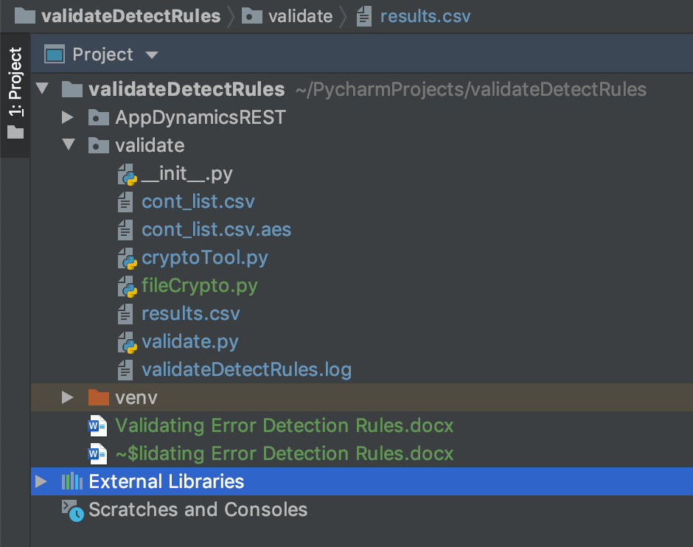

ValidateDetectRules – Main folder of the program

AppDynamicsREST – Folder containing AppDynamics REST SDK

Validate – Folder with python script files

cont_list.csv – Plain text file with controller information

cont_list.csv.aes – Encrypted file with controller information

cryptoTool.py – Script file to encrypt and decrypt a file

fileCrypto.py – Class containing the functionality for encrypting and decrypting files

results.csv – Plain text file with results

validate.py – Script file with the main logic

validateDetectRules.log – Log file with information of script execution

## Python Application